Electronic Instrumentation and Optoelectronics LAB

LAB3: Measuring with instruments. Systematic and random effects.
The aim of this LAB session is to compare the characteristics of the multimeter and oscilloscope when measuring the RMS value frequency of different signals.
In order to facilitate the configuration and acquisition of measurements from the instruments, we will develop a LabView program using specific instrument drivers (see annex information).

PRE-LAB Exercises.
Consider:
a) The estimation of the uncertainty from the instrument specifications is type B (non-statistical method). If the distribution type is unknown, it is assumed that the distribution (probability density function) is uniform. The distribution type of the multimeter (HP34401) specifications is known, we can deduce the distribution and the coverage factor k used in specifications from the manual (see p. 227).
b) Assume that the equipment is calibrated once a year and the laboratory temperature is between 18 ° C and 28 ° C. Disregarding the specification aging (aging).
c) If for a given measure is not specified the accuracy it means that the manufacturer does not warrant that this measure can be done correctly with this instrument (the measurement uncertainty is unknown).
d) In the function generator the accuracy is specified at 1 kHz, we must add the flatness specification for different frequencies than 1 kHz.
e) In some waveforms with high amplitude and low RMS value additional errors that are dependent on the peak factor must be considered. The crest factor is defined as the peak value divided by the RMS value.
f) Perform all theoretical calculations and measurements with the multimeter on the scale that provides less uncertainty.

To Do:
- From the specifications of the function generator calculate the standard uncertainty in the frequency and amplitude of a sinusoidal signal of 1 Vrms of amplitude and 1 Hz, 1 kHz and 1 MHz.

- From the specifications of the multímeter , calculate the standard uncertainty in frequency and amplitude of a sinusoidal signal of 1 Vrms of amplitude and 1 Hz, 1 kHz and 1 MHz (with a 5 ½-digit resolution with medium filter in AC coupling).

- Repeat the calculations for a square and triangular waves.

LAB exercises
LAB3-1.- Make a Labview VI, able to configure the amplitude, frequency and the kind of signal of the function generator. (Use the incomplete example VI provided on ATENEA).

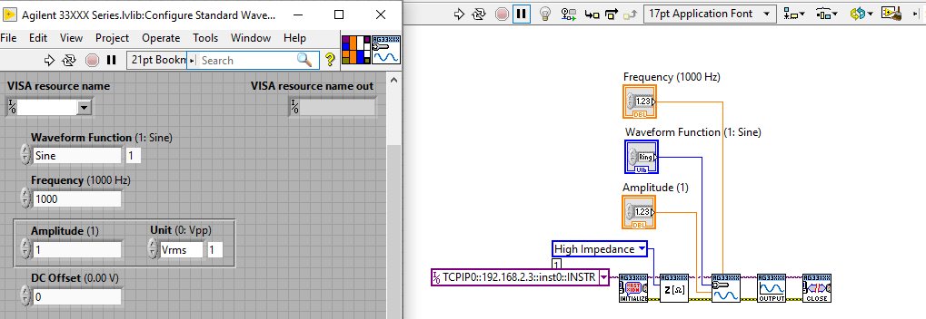

LAB3-2.- Make a Labview VI, able to measure the RMS value of a signal with the DMM. (Use the incomplete example VI provided on ATENEA).

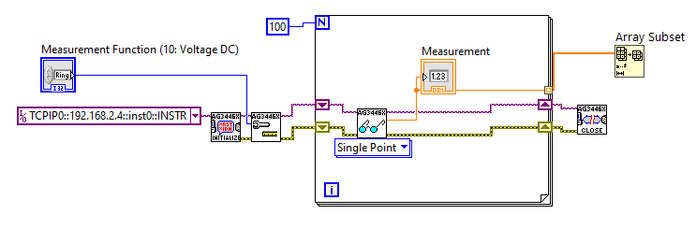
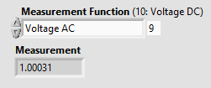

LAB3-3.- Measure with the multimeter the RMS value for each of the three signals (sinus, square and triangle) at the 3 different frequencies considered in the PRELAB exercices.

 | 1 Hz | 1 kHz | 1 MHz
Sinus | 0.19434 (out of range) | 0.999987 Vrms | 0 Vrms(out of range)
Square | 0.23754 Vrms (out of range) | 0.998265 Vrms | 0 Vrms(out of range)
Triangle | 0.135859 Vrms (out of range) | 1 Vrms | 0 Vrms (out of range)

LAB3-4.- Discuss the measures. Are in agreement with the specifications?

After the results obtained in the Lab we can conclude that the measures are in agreement with the specifications and the prelab work done.

LAB3-5 Make a Labview VI, able to measure the RMS value of a signal with the osciloscope. (Use the incomplete example VI provided on ATENEA).

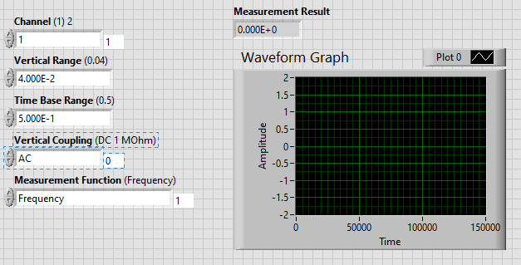
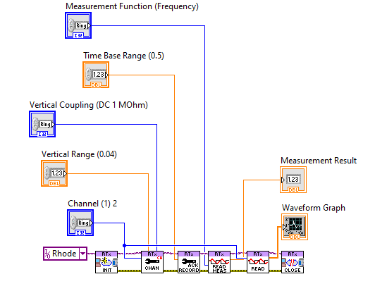
LAB3-6.- Repeat measures of LAB3-3 with the oscilloscope and compare with the previous ones. Are similar? What are the differences?

 | 1 Hz | 1 kHz | 1 MHz
Sinus | 0.5432 | 0.999903 | 1.001
Square | 0.63621 | 1.003 | 0.975210
Triangle | 0.54824 | 0.999715 | 1.001

The measures from 1kHz are similar to the ones obtained in the multimeter, but as the one from 1Hz is also out of range, even though is closer to the real value.
In the case of 1MHz were in range with the oscilloscope and the value is correct.
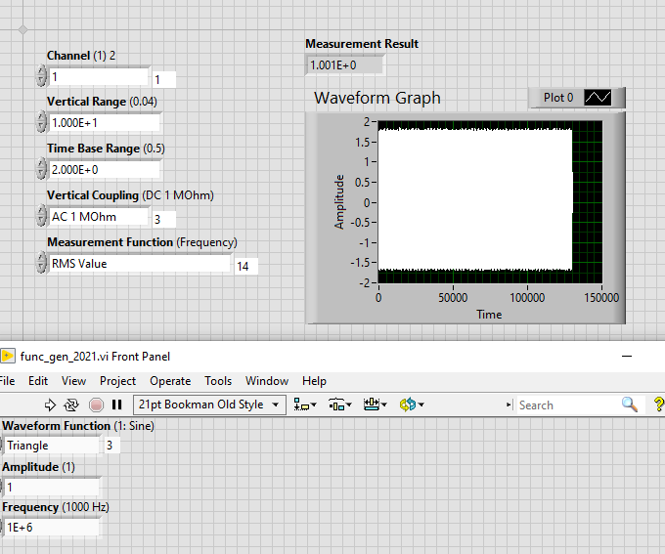

LAB3-7.- Configure the function generator for a frequency of 1 kHz. Take 100 measurements for each waveform with the multimeter and the oscilloscope. What is the Type A uncertainty of the measurements? Is it comparable with the Type B uncertainty? Why?

The type A uncertainty only takes into account the error in the measurement, whereas the type B also takes into account the instruments’ error. Therefore we can say that the Type B uncertainty is bigger than the type A and more precise.

Multimeter
Sinus

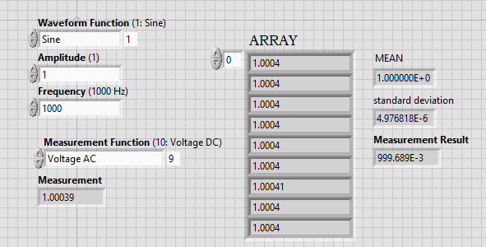

Square

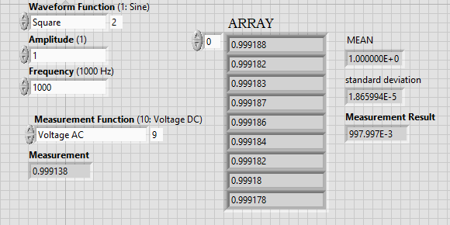

Triangle

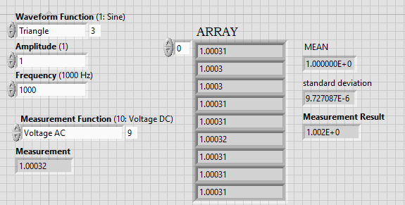
Oscilloscope
Sinus
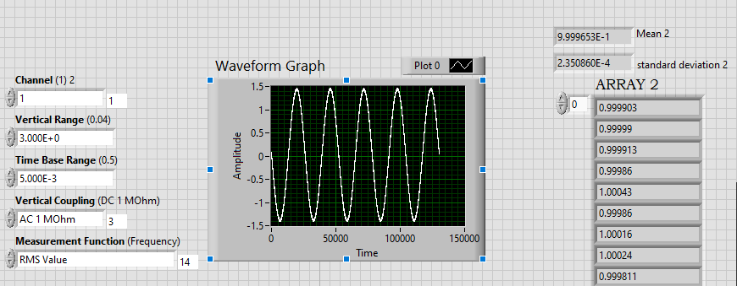
Square
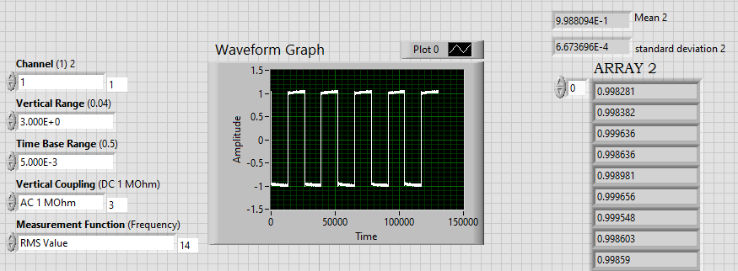
Triangular
